[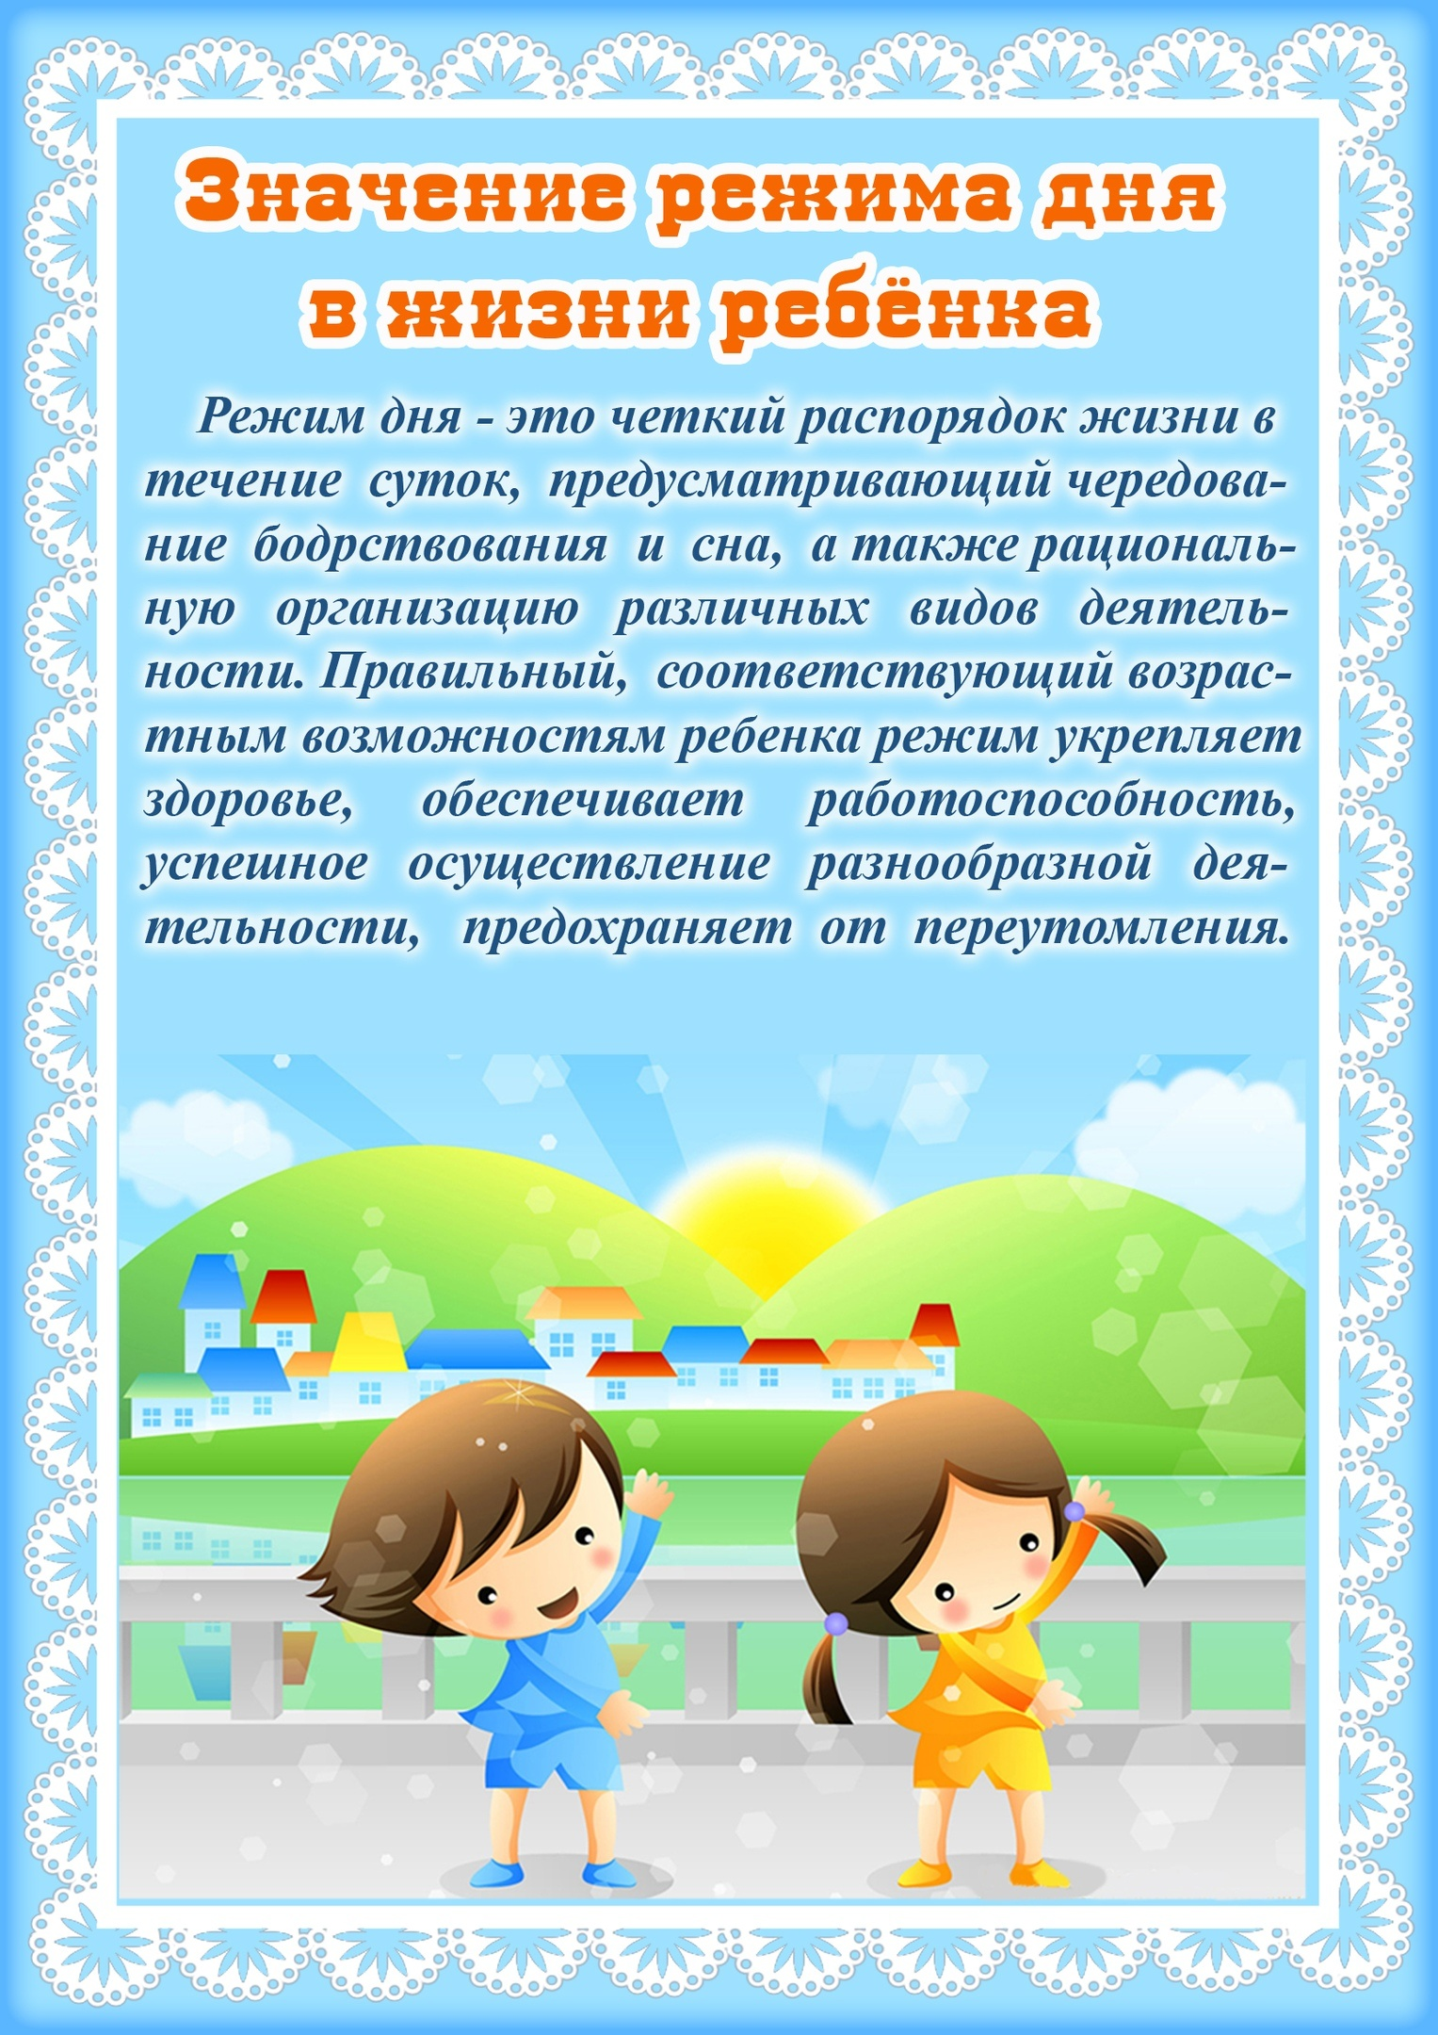](https://vk.com/photo-150736470_457243523)

[](https://vk.com/photo-150736470_457243524)

[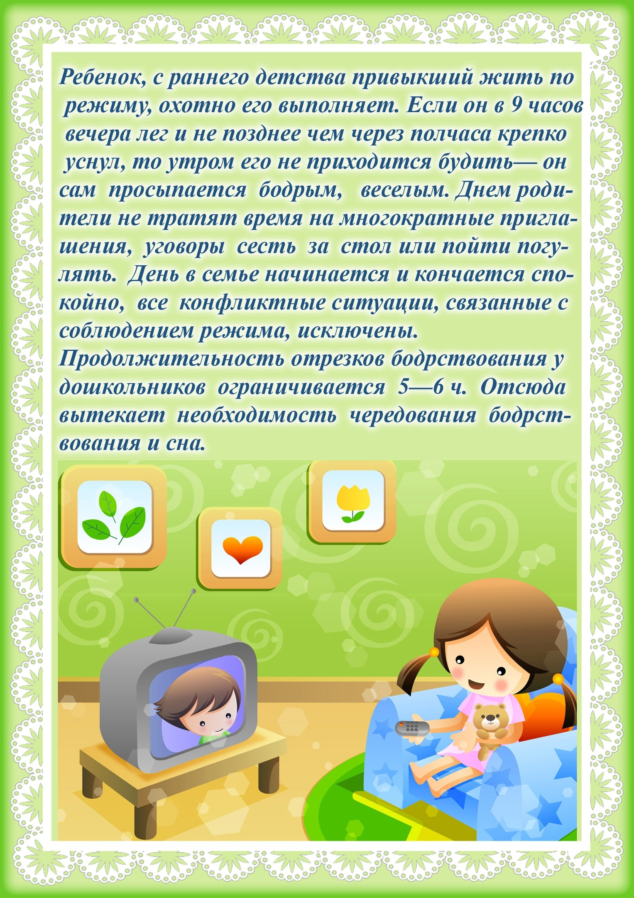](https://vk.com/photo-150736470_457243525)

[](https://vk.com/photo-150736470_457243526)